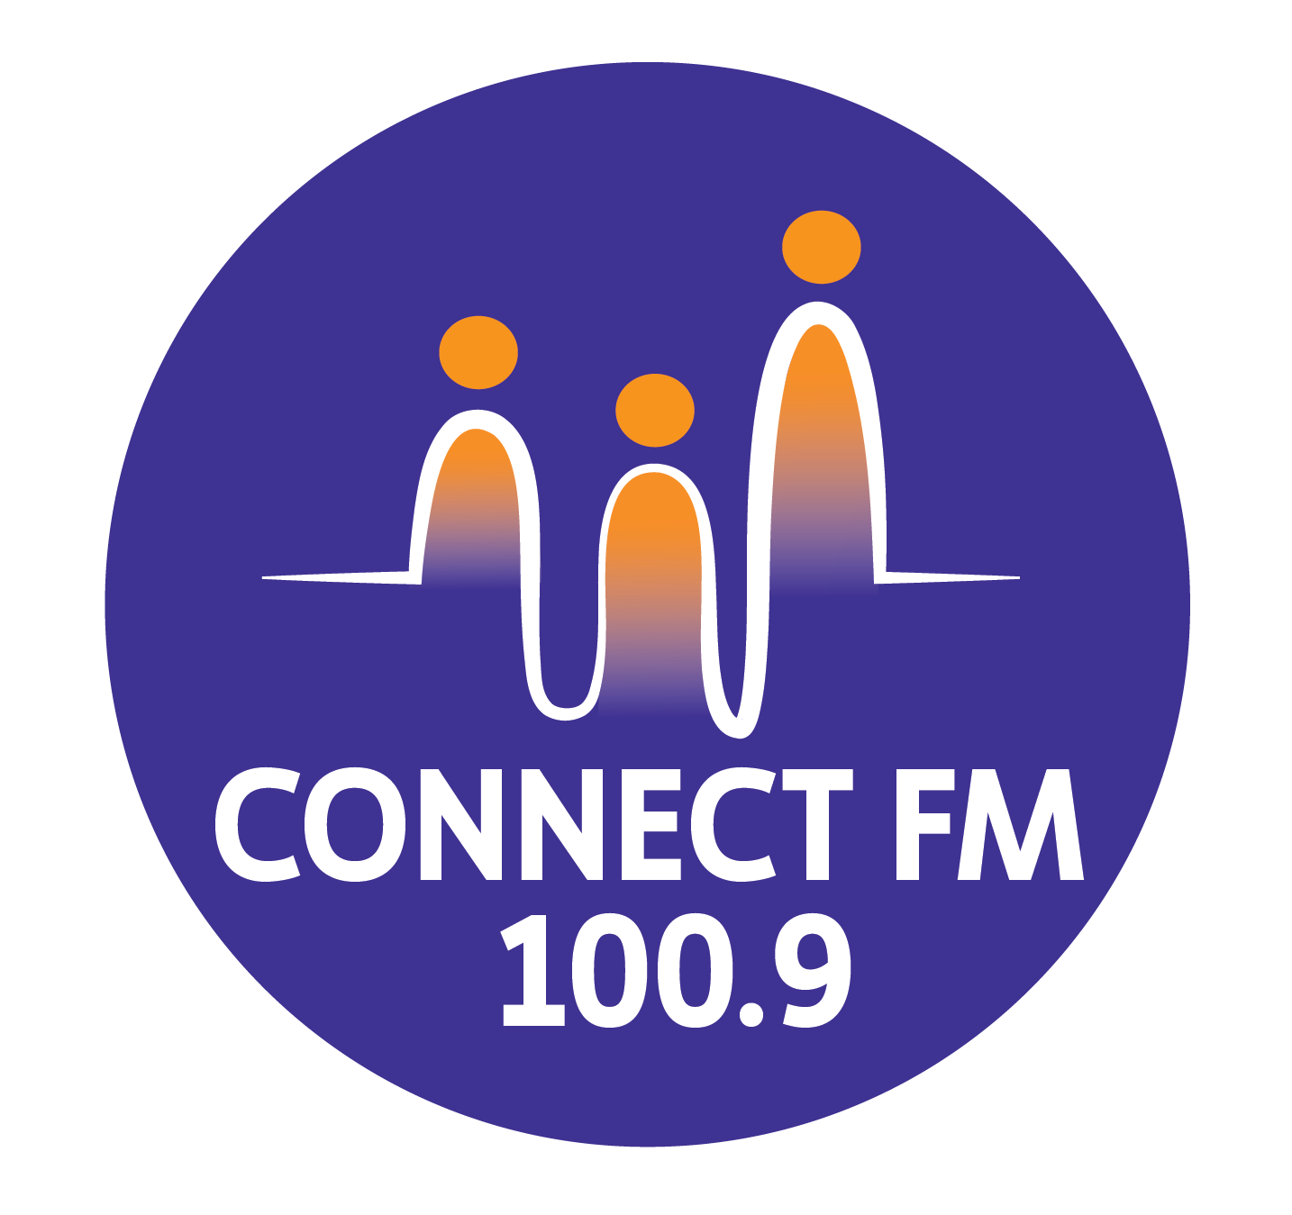
BANKSTOWN-AUBURN COMMUNITY RADIO INCORPORATED (BACR)
ABN 35 737 985 863

WORKPLACE HEALTH AND SAFETY POLICY

1. Policy Statements
The purpose of this policy is to outline BACR/CONNECT FM 100.9’s commitment to workplace health and safety. The development and maintenance of systems of work that are safe and without risk to health is a core managerial responsibility.
BACR/CONNECT FM 100.9 acknowledges the right of staff, volunteers, and members to adequate workplace health and safety standards and will make every reasonable effort to provide them. The maintenance of these standards, in accordance with the Work Health and Safety Act 2011, requires the active co-operation of all persons involved with the station.

2. General Requirements and Conduct
Participation and Reporting
- Staff and volunteers must familiarize themselves with the safety criteria for their specific tasks and comply with WHS practices at all times.
- All occupants must work in a safe manner and take reasonable care for the health and safety of others.
- Any possible breach of WHS or any identified hazard must be reported promptly to the Management Committee or the Station Manager.
- No person shall misuse equipment or facilities provided for health, safety, or welfare.
- Psychosocial Safety: BACR/CONNECT FM 100.9 is committed to a workplace free from bullying, harassment, or threats of violence. In accordance with 2026 standards, the station will proactively identify and manage psychosocial hazards, including high job demands and exposure to distressing content, providing support to those in high-risk programming roles.
Alcohol, Drugs, and Smoking
- All BACR/CONNECT FM 100.9 premises and training venues are strictly alcohol, drug, and illegal substance-free workplaces.
- Any person found under the influence of such substances while on duty is liable to disciplinary action, summary dismissal, and potential legal action.
- Smoke-Free Environment: Smoking is strictly prohibited inside the premises.
- Smoking is not permitted within 20 metres of any outside door, window, or air conditioning unit used by the station.
- This non-smoking rule extends to Outside Broadcasts (OBs) and any event where station equipment or personnel are present.

3. Operational Safety Procedures
Equipment and Studios
- Members must report any equipment malfunction and ensure that faulty equipment is not operated.
- Warning signs or "Out of Service" tags must not be removed except by the person who performed the repair.
- Studio Hygiene: No food or drinks are allowed in the broadcast studios, control room, or music library. Refreshments are restricted to the Office area.
Remote and After-Hours Work
- Outside Broadcasts (OB): A mandatory Site Safety Check must be conducted at all OB locations to identify trip hazards (cables), weather risks, and crowd control issues before going on air.
- Working Alone: For late-night presenters or those working alone, a mandatory "Check-in/Check-out" procedure is in effect. All personnel must ensure doors remain locked and follow the station’s after-hours security protocol.

4. Incident Management and Review
Injury Procedures
- All injuries, no matter how minor, must be recorded in the Register of Injuries Book kept at the station office.
- For serious injuries, a WorkCover incident report, a Doctor’s statement, and Witness statements must be completed immediately and submitted to the Secretary.
Governance and Review
- The Management Committee will include a standing Agenda Item at every monthly meeting to discuss WHS matters, review reported hazards, and ensure ongoing compliance.
- This policy will be reviewed following any major incident to ensure practices and procedures remain effective.
APPROVED BY THE BACR/CONNECT FM 100.9/CONNECT FM 100.9/CONNECT FM 100.9 MANAGEMENT COMMITTEE 2010/REVISED BY THE MANAGEMENT COMMITTEE 2025/UPDATED FOR 2026 COMPLIANCE

