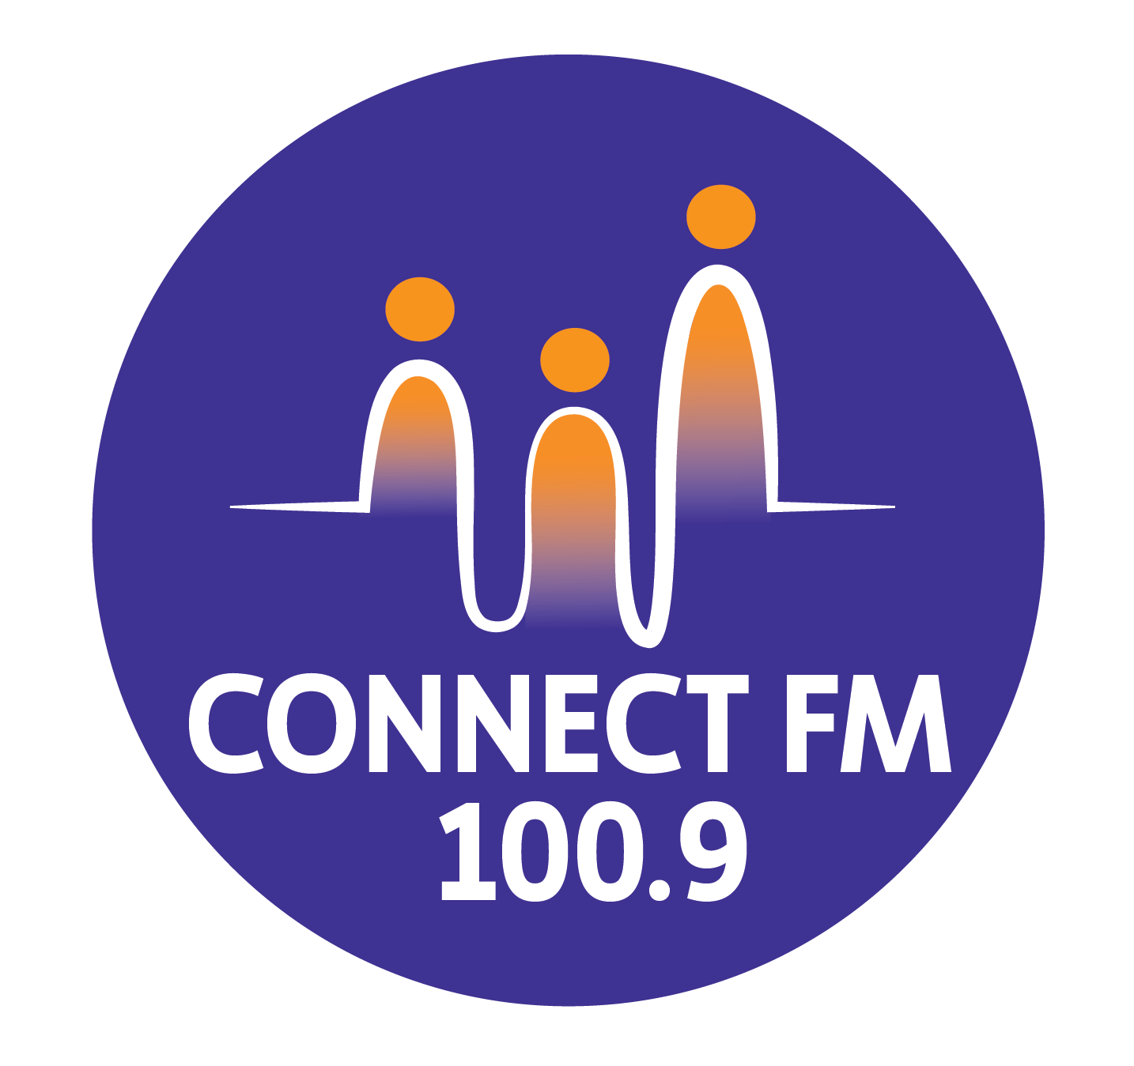
BANKSTOWN-AUBURN COMMUNITY RADIO INCORPORATED (BACR/CONNECT FM 100.9)
ABN 35 737 985 863

POLICY 3.4: CHILD PROTECTION AND PROGRAMMING PRACTICES (REVISED 2026)
1. PURPOSE AND SCOPE
The objective of this policy is to fulfill the requirements of CBAA Code of Practice 3.4, ensuring ConnectFM 100.9 implements programming practices that protect children from harmful material while avoiding concealing the real-world complexities of life. A child is defined as any person under 18 years of age. This policy applies to all broadcasters, guests, and station personnel.
2. PROGRAMMING STANDARDS
The Management Committee strictly opposes the broadcast of any material that harms children or contravenes community standards.
- Prohibited Content: Broadcasters must not air material promoting the mistreatment of children, physical or psychological abuse, violence, or sexually explicit/pornographic content.
- Language and Tone: Strong swearing is never permitted, and presenters must exercise caution regarding sexual references or explicit language that could distress parents or harm minors.
- Context and Scheduling: Broadcasters must consider the "General" nature of the station's license, the time of day (specifically before 10 PM), and the propensity of material to alarm or shock.
- Artistic Exception: While protecting children, the station reserves the right to broadcast legitimate artistic statements to avoid unnecessary censorship.

3. BROADCASTER OBLIGATIONS
Before commencing any program, responsible parties must:
- Complete Training: Broadcasters must undergo training on community standards and the "Broadcaster Information Kit".
- Acknowledge the Checklist: All presenters must utilize the Child Protection Checklist, adhering to the industry standard: "If in doubt, leave it out".
- Formal Agreement: Sign an "Airtime Agreement" contract that stipulates the conditions required to protect children from harmful exposure.
- Accept Accountability: Presenters acknowledge that a failure to comply with the Code is a failure of the licensee; breaches may result in immediate program suspension or termination.
ANNEX: NATIONAL CHILD SAFE STANDARDS & WORKPLACE PROTOCOLS (2026)
To ensure full compliance with the National Child Safe Standards and modern WHS requirements, ConnectFM 100.9 adopts the following workplace protocols:
A. Working With Children Checks (WWCC)
- All Management Committee members, staff, and regular volunteers must hold a current, verified Working With Children Check if their role involves direct interaction with minors or the supervision of youth programs.
- The Station Manager will maintain a centralized register of WWCC numbers and expiry dates.
B. Physical and Digital Safety
- Supervision: No person under the age of 18 is permitted in the broadcast studios or office without the supervision of a parent, guardian, or a station official holding a valid WWCC.
- Photography and Privacy: Written parental consent must be obtained before any photographs or identifiable recordings of a minor are published on the ConnectFM website or social media platforms.
C. Content Warnings
- If a segment contains themes that are "the real world" but potentially distressing (e.g., news regarding youth crime or social issues), the broadcaster must provide a clear verbal warning prior to the segment to allow parents to exercise discretion.
D. Reporting Hazards
- Any broadcaster who becomes aware of a guest or participant displaying inappropriate behavior toward a minor must report the incident to the President or Station Manager immediately as a critical safety breach.

APPROVED BY THE MANAGEMENT COMMITTEE 2010 / REVISED JANUARY 2025 / UPDATED MARCH 2026

Attachment 1 to Policy and Programming Practices to Protect Childen from Harmful Material

BACR/Connect FM 100.9 Checklist For Complying With Code 3.4 "Not Broadcast Material Harmful To Children"

- Although BACR/Connect FM 100.9 supports the right of artists to express themselves and respects your right to freedom as a broadcaster, this does not permit you to play or broadcast material, including sponsorship announcements or reference to video or computer games, that does not conform with community standards or that would be reasonable considered to be harmful to children. Broadcasters must take responsibility for their program to avoid dialogue or music that may lead to or contain:
  - Mistreatment of children
  - Physical abuse of children
  - Psychological and emotional abuse of children
  - Violence to children
  - Sexually explicit or pornographic material
  - Swearing
  - Bullying
  - Occult
  - Suicide

- Strong swearing is never permitted on any BACR/Connect FM 100.9 program.
- When broadcasting your program you need to consider its content with reference to:
  - BACR/Connect FM 100.9 operates under a General licence issued by the Australian Communications and Media Authority that investigates complaints from the public about broadcast content that does not conform with community standards or may be harmful to children
  - The time of the day and who may be listening at that time of the day
  - Are children listening at that time of the day, e.g., is it before 10 PM?
  - What would most listeners think of the content of the material you play?
  - If you do decide to broadcast mildly offensive material you should give a language warning and explain to listeners why you have chosen to play the material
  - Have you asked the Station Manager or someone on the Management Committee for their opinion on the suitability of the material?
  - If a complaint is lodged about your choice of material, you will be required to explain in detail if you gave proper consideration to the audience, context, degree of explicitness, strength of the language, was your intention and the propensity of the material directed to alarm/distress/shock the audience and what was the social importance of it.
  - Material broadcast merely to alarm, distress and/or shock the audience is prohibited on BACR/Connect FM 100.9.
- BACR/Connect FM 100.9 requires the industry standard of "if in doubt, leave it out" be followed by broadcasters.
- Failure by a broadcaster to give proper consideration to the above guidelines or any deliberate breach of these guidelines will result in the suspension or termination of your program and/or of the voluntary services you may have offered BACR/Connect FM 100.9

APPROVED BY THE MANAGEMENT COMMITTEE 2010.
REVISED JANUARY 2025.

