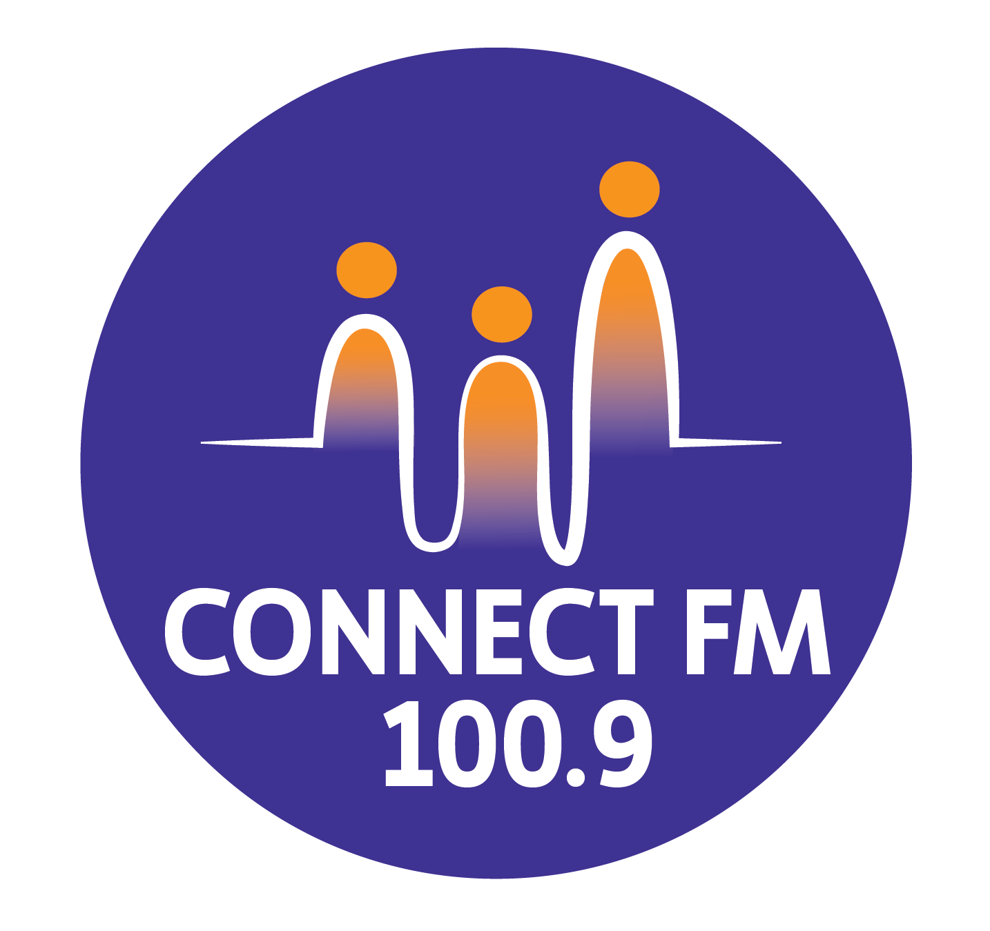
BANKSTOWN-AUBURN COMMUNITY RADIO INCORPORATED (BACR/CONNECT FM 100.9)
ABN 35 737 985 863

BROADCASTER INFORMATION CHECKLIST (REVISED 2026)
1. Administrative & Legal Foundation
[ ] Have you completed, signed, and submitted your Airtime Application Form?
[ ] Have you read, understood, and signed the Broadcaster Airtime Agreement?
[ ] Have you completed the mandatory CBAA Online Codes of Practice course?
[ ] Have you provided your Working With Children Check (WWCC) number to the office?
[ ] Are you aware of your specific hourly airtime fees and payment schedule?
2. Programming & Content Standards (Code 3)
[ ] Do you know how to perform a respectful Acknowledgement of Country?
[ ] Do you know to prioritize Lived Experience (authentic voices) for community segments?
[ ] Do you know how to TAG sponsorship announcements and adhere to the 5-minute rule?
[ ] Do you know you are strictly prohibited from swearing or making discriminatory comments?
[ ] Do you know the station's strict policy for reporting on suicide and mental health?
[ ] Do you know how to use Language Warnings for adult or potentially distressing content?
[ ] Are you aware of the Australian Music minimum quotas (25% General / 10% Ethnic)?
3. Technical & Studio Operations
[ ] Do you know how to operate the broadcast panel, including the "Kill" switch for talkback?
[ ] Do you know how to play station sweepers and Community Service Announcements (CSAs)?
[ ] Do you know how to report equipment failure or technical hazards immediately?
[ ] Do you know to thank the previous show and end your program exactly on time?

4. Station Etiquette & Safety
[ ] Do you know you must sign the Attendance Book and Music Log Sheet every shift?
[ ] Do you know where to go for a Safety Debrief after broadcasting traumatic or difficult topics?
[ ] Do you understand that station reputation rules apply to your professional social media?
[ ] Do you know that smoking, alcohol, and food are strictly prohibited in the studios?

APPROVED BY THE MANAGEMENT COMMITTEE 2010 / REVISED JANUARY 2025 / UPDATED MARCH 2026

