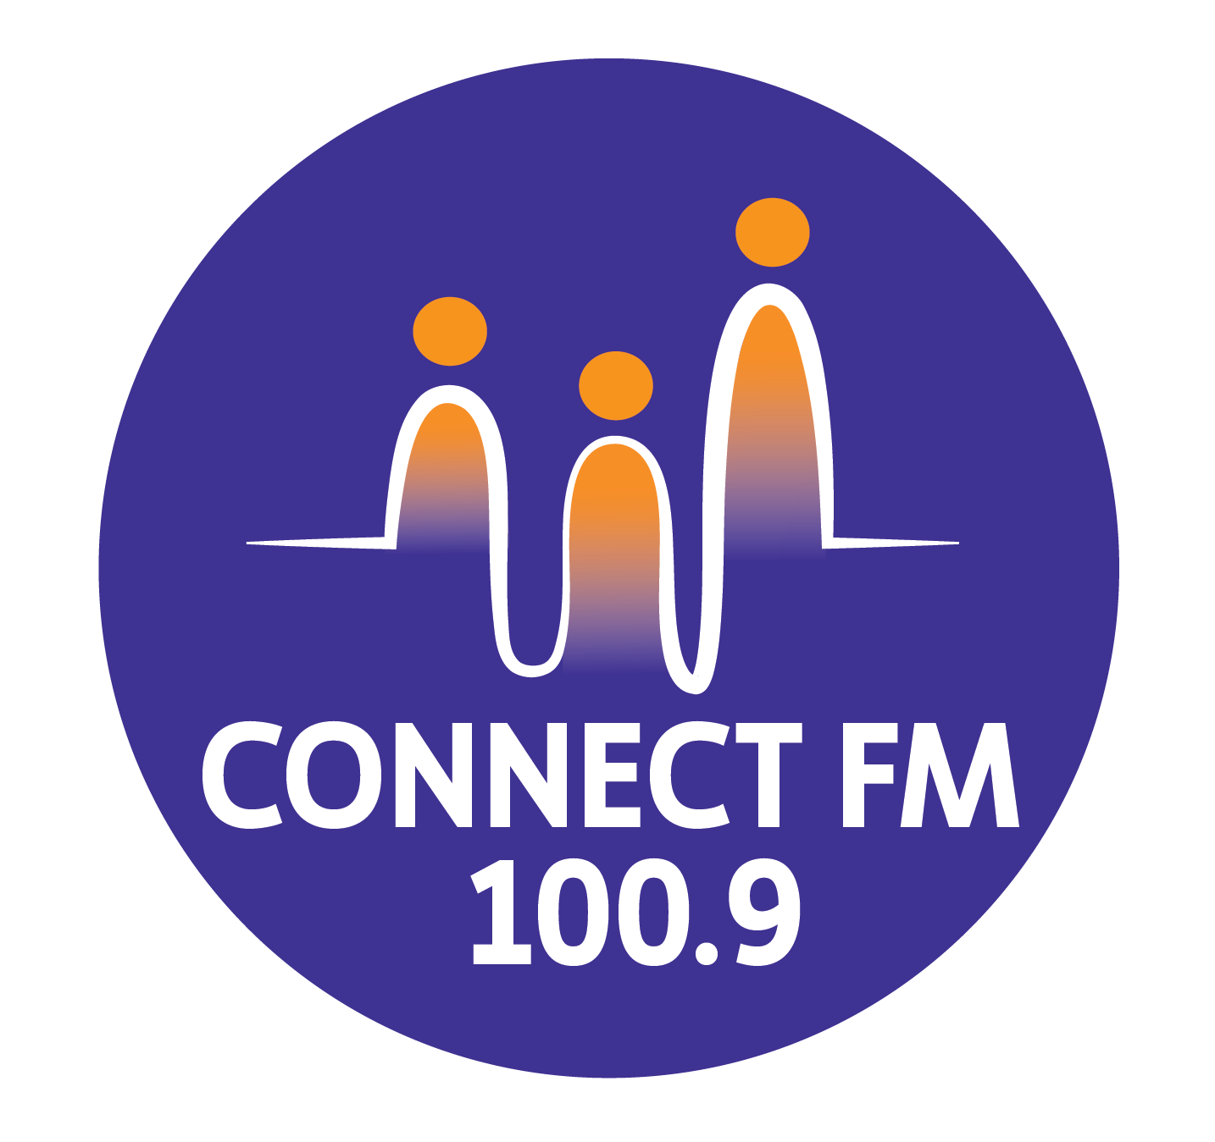
BANKSTOWN-AUBURN COMMUNITY RADIO INCORPORATED (BACR/CONNECT FM 100.9)
ABN 35 737 985 863

POLICY 9.3a: MISSION, MOTTO, AND VISION (REVISED 2026)
1. Mission Statement
Bankstown-Auburn Community Radio (ConnectFM 100.9) will provide, promote, and advance a sustainable, high-quality community radio service for our licensed broadcast area. We achieve this by:
- Encouraging local community access and active involvement in all station levels.
- Complying enthusiastically with relevant legislation, such as the Broadcasting Services Act 1992, and the Community Radio Codes of Practice.
- Catering harmoniously and equitably for the diverse, evolving needs of both English and non-English speaking groups within our multicultural community.
- 2026 Mandate: Prioritizing the voices of those with Lived Experience to ensure authentic representation across all programming sectors.
2. Our Motto
Connect FM 100.9 – Connects you to the local community.
3. Vision Statement
Our vision is to fully satisfy and significantly increase the demand for community radio services in our area, culminating in:
- Inclusive Programming: A program guide that is nearly or completely full, offering "something for everyone" through a diverse collection of inclusive programs.
- Community Participation: A significant portion of the local community being directly involved in the provision and selection of our programs.
- Energetic Volunteerism: A large, positive base of members and volunteers participating in the management, administration, and operations of the station.
4. Strategic Objectives for 2026
We envision a station that:
- Reflects Lived Experience: Provides a platform where community members speak for themselves on issues that affect them directly.
- Honors First Nations: Fosters deep links with the Indigenous community and acknowledges the Traditional Owners of our land.
- Maintains Independence: Demonstrates absolute editorial and management independence from external political or commercial influences.
- Empowers Youth: Provides meaningful opportunities for young people to lead and innovate within radio media services.
- Ensures Quality: Delivers artistically diverse, informative, and entertaining programming that enlivens the local social climate.

APPROVED BY THE MANAGEMENT COMMITTEE 2010 / REVISED DECEMBER 2025 / UPDATED MARCH 2026

