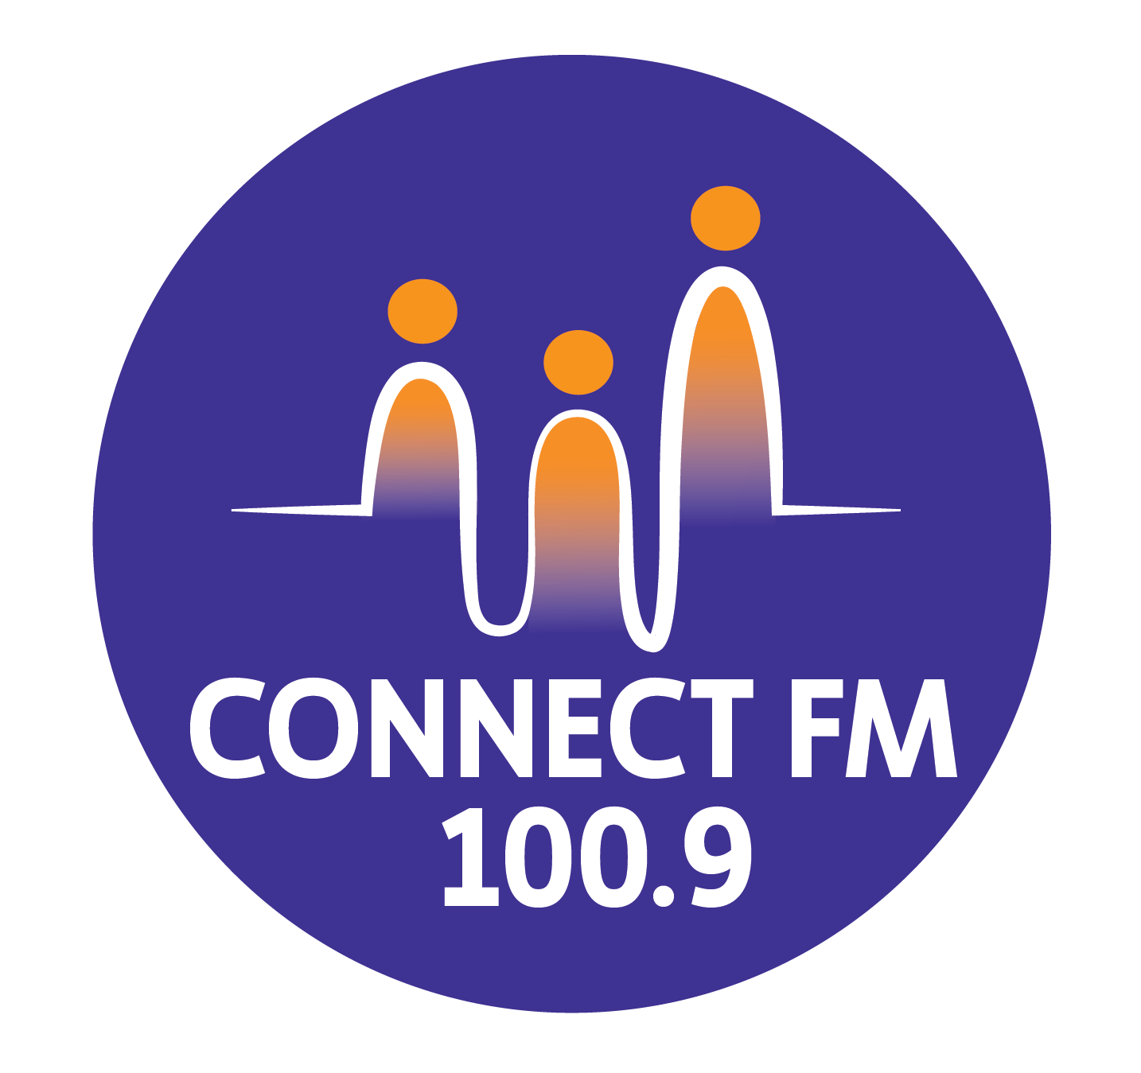
BANKSTOWN-AUBURN COMMUNITY RADIO INCORPORATED (BACR)
ABN 35 737 985 863

BROADCAST TRAINING CHECKLIST
- Have they completed, signed and given their Airtime Application Form to 2BACR?

- Is BACR aware of the sponsors they want to make sponsorship announcements for?

- Do they know how to operate the panel?

- Are they aware of the Radio Station Rules?

- Do they know what their specific hourly airtime fees are?

- Have they read, understood and signed a Broadcaster Airtime Agreement?

- Do they know to play a 2BACR jingle or mention 2BACR during their program each hour.

- Do they know about playing station sponsorship announcements?

- Do they know how to TAG all sponsorship announcements?

- Do they know about the 5 minutes sponsorship rule?

- Do they know to make or play a community service announcement every hour?

- Do they know how to use the Talkback facility?

- Do they know how to stop unwanted comments going to air with the "kill" switch?

- Do they know how to back announce?

- Do they know to thank the show they have just taken over from?

- Do they know they are never allowed to swear on air?

- Do they know they are not allowed to make certain discriminatory comments?

- Do they know they have to uphold community standards, especially regarding children?

- Do they know about adult warning content?

- Do they know they may not advertise, especially prohibited substances & tobacco goods?

- Do they know about regulations on the minimum Australian music content?

- Do they know about Station policy if reporting on suicide and mental health issues?

- Do they know who to report equipment failure or equipment problems to?

- Do they know to end their program on time?

- Do they know they have to sign an attendance sheet and announcements logsheet?
APPROVED 2010/REVISED BY THE MANAGEMENT COMMITTEE 2025/UPDATED FOR 2026 COMPLIANCE

