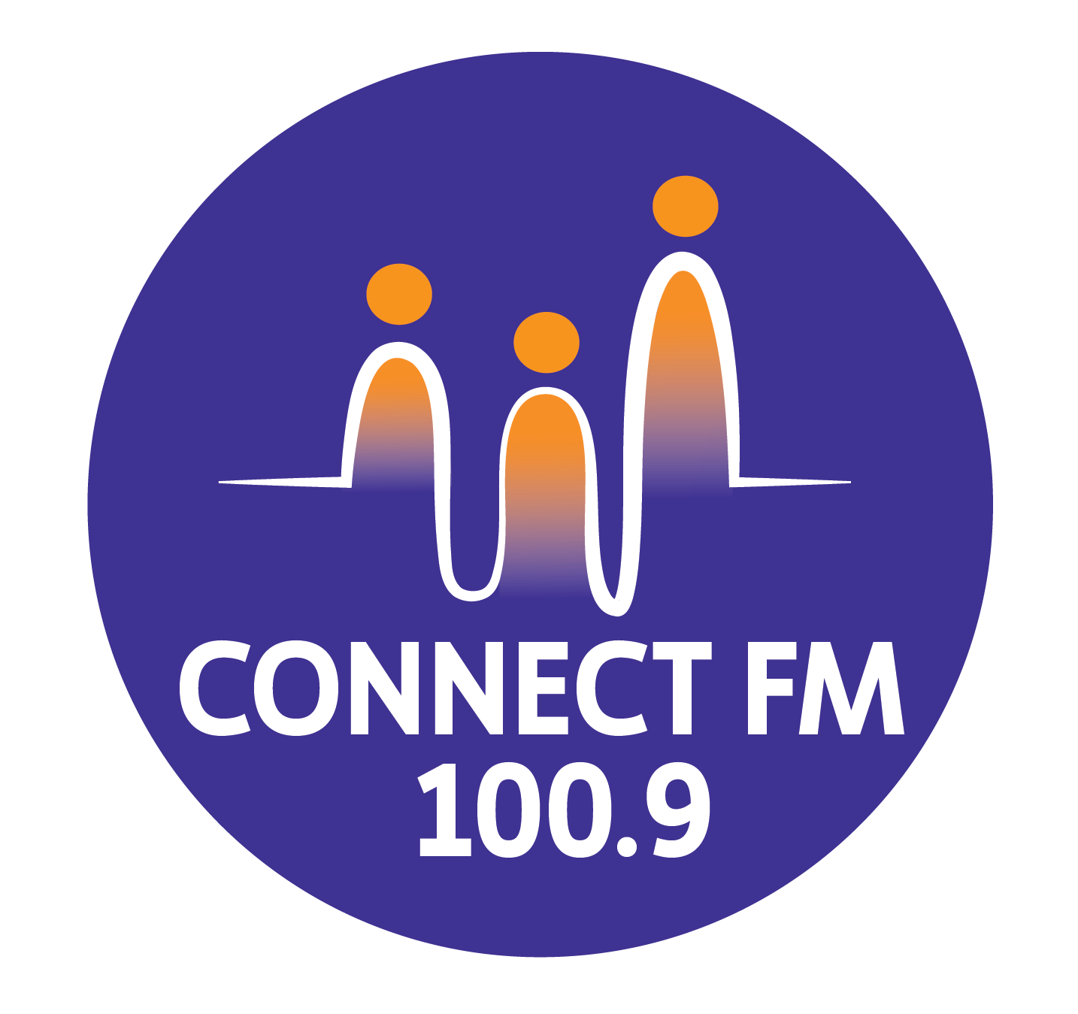
BANKSTOWN-AUBURN COMMUNITY RADIO INCORPORATED (BACR)
ABN 35 737 985 863

INDIGENOUS POLICY STATEMENT
Commitment to the Aboriginal and Torres Strait Islander Residents of Australia is a policy promoted strongly by Federal, State and Local Governments, including Bankstown and Auburn City Councils. Bankstown-Auburn Community Radio Inc (BACR/CONNECT FM 100.9) has an obligation to observe and implement the Principles of Reconciliation with Indigenous Peoples, especially those residing in the Bankstown City and Auburn City areas.
- BACR/CONNECT FM 100.9 has developed initiatives to promote the Indigenous population in the Bankstown and Auburn areas, such as, by:
- Defining BACR/CONNECT FM 100.9's commitment to Reconciliation with Indigenous People.
- Providing opportunities for Indigenous people of the licensed area to participate in BACR/CONNECT FM 100.9 activities, and the media sector in general.
- Ensuring the station’s programming reflects a commitment to cultural safety and the prioritization of First Nations voices on First Nations issues.
Recognition and Respect
BACR/CONNECT FM 100.9 Inc. acknowledges that:
- Indigenous peoples were the first population of the Bankstown and Auburn licensed area.
- Aboriginal and Torres Strait Islander peoples have unique customs and traditions, and a spiritual relationship with the land.
- They have a right to live according to their own beliefs, values and customs.
- Protocol: The station will perform an Acknowledgement of Country at the commencement of all station meetings and significantly throughout the broadcast day to honor the Traditional Owners of the land where our studios are located.

Strategic Support and Collaboration
BACR/CONNECT FM 100.9 Inc supports:
- Indigenous and Non-Indigenous Australians working together for an agreement on Reconciliation and to overcome poverty and disadvantage for the Indigenous.
- The need to improve understanding by the local community of Indigenous peoples.
- The need to ensure access for Indigenous peoples to broadcasting services and programs for the Bankstown and Auburn areas.
- Consultation: A commitment to consult with local Aboriginal Land Councils and Indigenous media organizations when producing content that impacts or represents First Nations communities.

Commitments to Action
BACR/CONNECT FM 100.9 commits to:
- Developing and promoting Indigenous involvement in the local community radio service.
- Taking into account the financial situation of Indigenous peoples wanting to participate in the operations and management of the service.
- Providing training for Indigenous peoples wanting to increase their knowledge, understanding and appreciation of community radio services.
- Lived Experience: Prioritizing the voices and perspectives of Aboriginal and Torres Strait Islander people when broadcasting on First Nations topics, ensuring content is led by those with relevant lived experience.
- Cultural Safety: Ensuring all broadcasters receive basic training in cultural awareness and the avoidance of stereotypes or derogatory depictions of Indigenous peoples.
- Exploring and considering strategies to improve the chances of participation of Indigenous peoples, such as increased communication with local elders and community groups
APPROVED 2010/REVISED BY THE MANAGEMENT COMMITTEE 2025/UPDATED FOR 2026 COMPLIANCE

