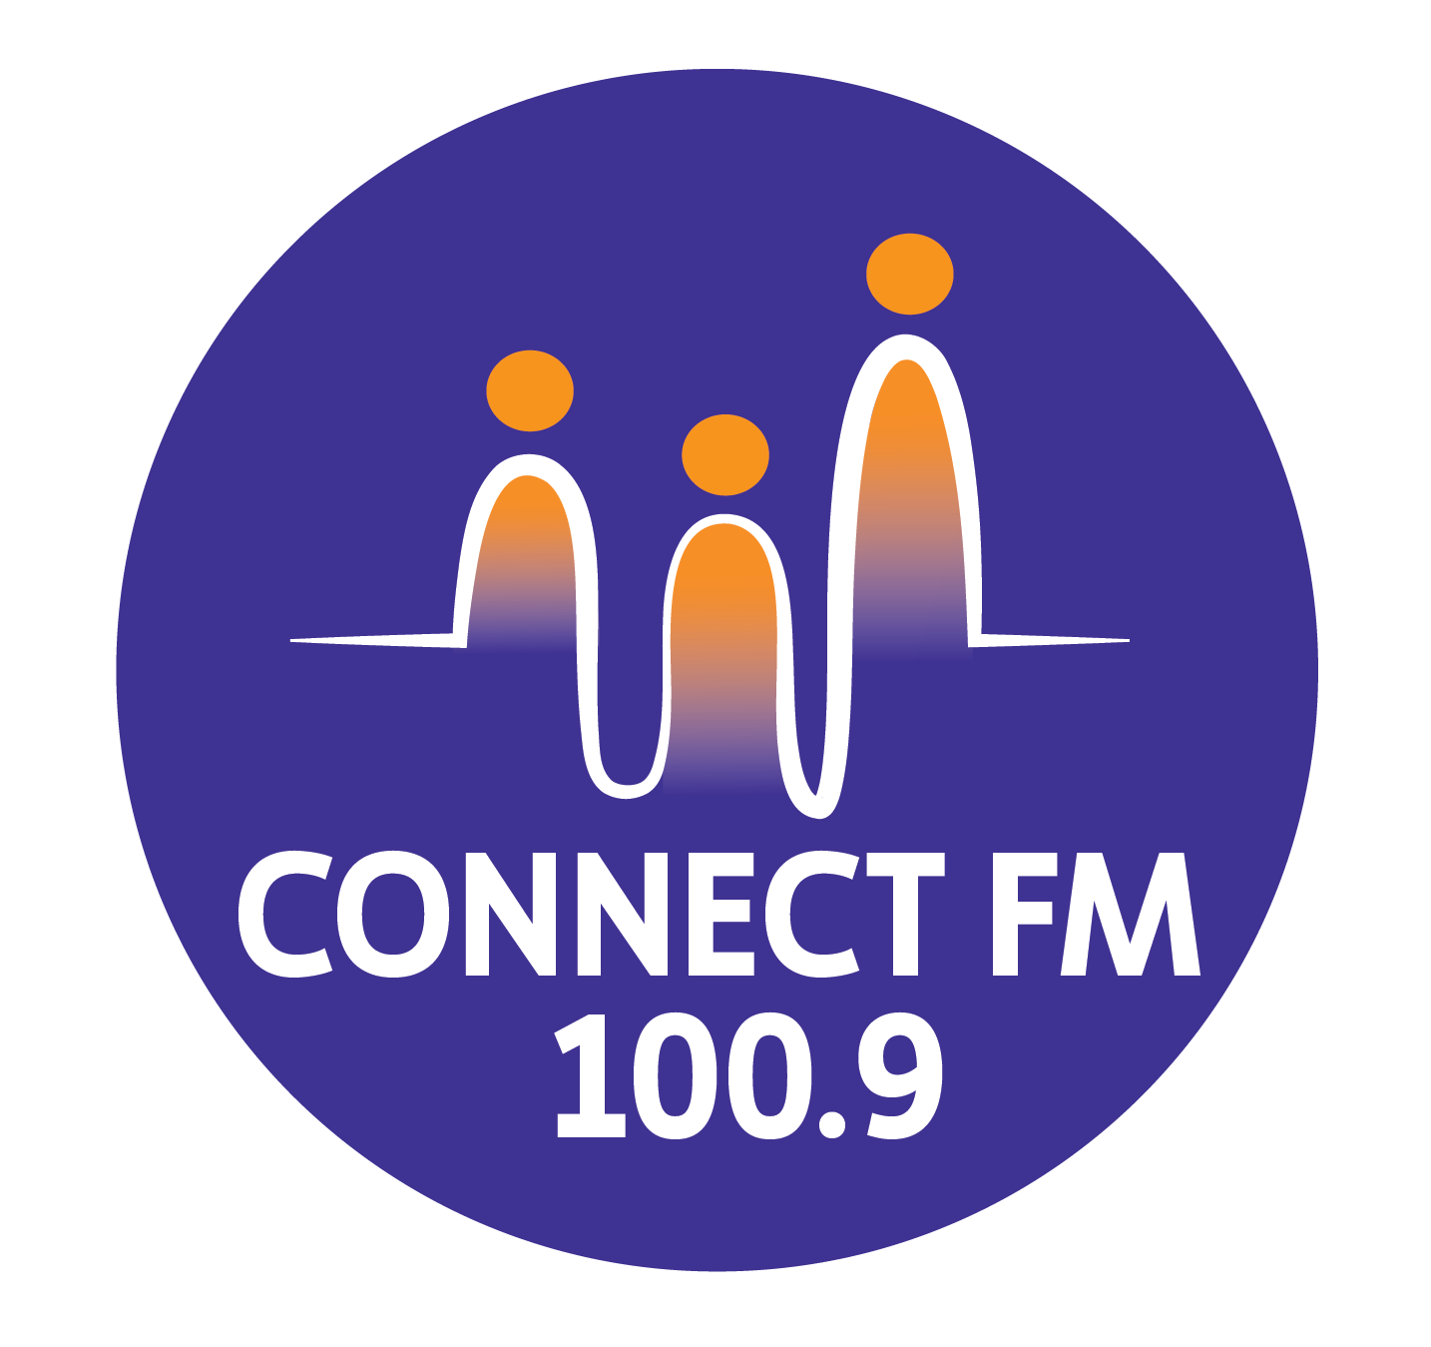
BANKSTOWN-AUBURN COMMUNITY RADIO INCORPORATED (BACR)
ABN 35 737 985 863

AGE GROUP CARE POLICY STATEMENT
The Federal, State and Local Governments, including Bankstown and Auburn City Councils, advocate policies to foster and protect the interest of specific age groups, identified in this policy as CHILDREN, YOUNG PEOPLE, and SENIORS.
Bankstown-Auburn Community Radio Inc (BACR) considers it has an obligation to observe and implement a Policy on caring for the various age groups of people in the licensed area who listen to the community broadcast service and who may wish to participate in the operations and programming of BACR/CONNECT FM 100.9.
BACR/CONNECT FM 100.9 has developed initiatives to promote the interest of various age groups residing within the Bankstown and Auburn areas, such as, by:
- Defining BACR/CONNECT FM 100.9's commitment to various age groups of the local community
- Providing opportunities for persons from various age groups to participate in BACR/CONNECT FM 100.9 activities, and the media sector in general
- Pursuing programs broadcast on 2BACR/CONNECT FM 100.9 that are appropriate to the specific age group being targeted
- Broadcasting Information Releases that disseminate important, relevant information specific to the various age groups in a timely way
- Ensuring that all age-based broadcasts and digital interactions are within legislative regulations and guidelines, including the National Child Safe Standards.

Children (0 – 12 Years)
BACR/CONNECT FM 100.9 advocates the following for Children within the licensed area:
- Child Safety & Protection: In accordance with the 2025 CBAA Codes and National Child Safe Standards, all personnel working with children must hold a valid Working With Children Check (WWCC) and undergo mandatory reporting induction.
- Supervised Participation: Children may participate in station operations and programming only under the direct supervision of a responsible adult and a WWCC-cleared staff member.
- Information Dissemination: BACR/CONNECT FM 100.9 is committed to informing parents and children about:
  - Children's services through Local Councils (e.g., Bankstown Children's Services Forum, Child Protection Interest Group).
  - Events such as Children’s Week, Playgroups, and School Holiday programs at local libraries.
  - Health and eSafety programs via Auburn and Bankstown Local Councils to ensure online security.

Young People (13 – 25 Years)
BACR/CONNECT FM 100.9 advocates the following for Young People within the licensed area:
- Youth-Led Content: In accord with social inclusion strategies, the station encourages content created by young people, ensuring their "lived experience" is prioritized in youth-focused discussions.
- Participation Standards: Young people aged 13–17 may participate in broadcasting with parental consent and appropriate supervision; those aged 18 or older may participate unsupervised.
- Support Services: Commitment to informing Young People about:
  - Local Youth Information Services ("Links For Young People") and employment initiatives.
  - Local Council initiatives, including Youth Week, creative workshops, and skate park locations.
  - Digital literacy and mental health resources specific to the challenges of young adulthood.

Seniors (65 Years and Older)
BACR/CONNECT FM 100.9 advocates the following for Senior citizens within the licensed area:
- Active Participation: Seniors have a right to participate fully in the operations, governance, and programming of BACR/CONNECT FM 100.9.
- Advocacy and Information: Commitment to informing Senior citizens about:
  - Nutrition, health maintenance (body, mind, and dental), and dementia services.
  - Abuse Prevention: Actively broadcasting information regarding elder abuse prevention services.
  - Digital Literacy: Providing segments aimed at increasing media literacy and navigating digital transitions to prevent online fraud and social isolation.
- Community Connection: Promoting local activities and social groups to foster community harmony and engagement.
APPROVED 2010/REVISED BY THE MANAGEMENT COMMITTEE 2025

