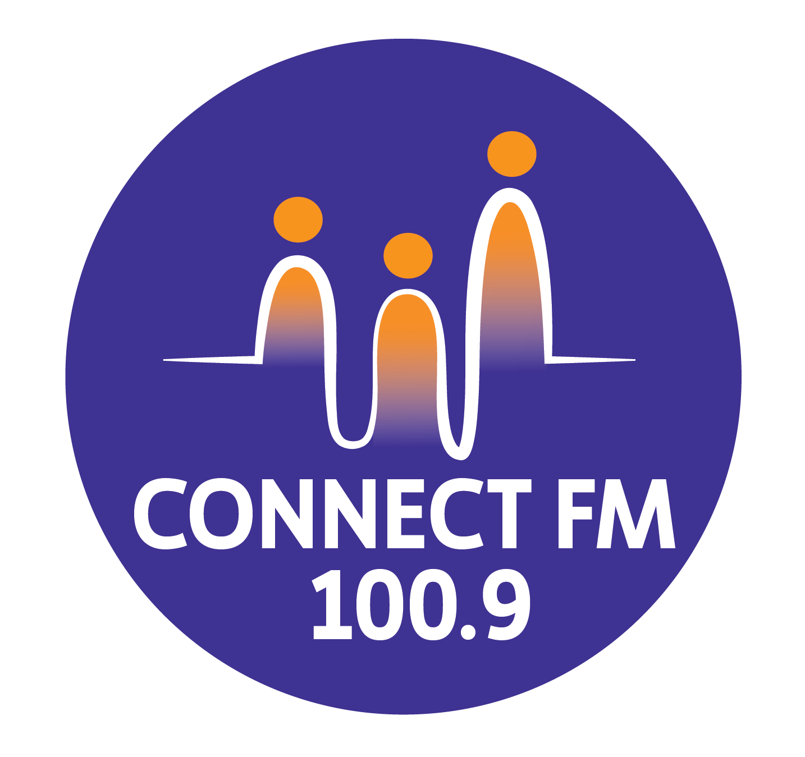
BANKSTOWN-AUBURN COMMUNITY RADIO INCORPORATED (BACR)
ABN 35 737 985 863

COMPLAINTS FROM MEMBERS AND VOLUNTEERS-PRO FORMA

BACR/Connect FM 100.9 Complaints Pro Forma
BACR/Connect FM 100.9 Inc. will treat all complaints from members and volunteers in a civil and polite manner. BACR/Connect FM 100.9 Inc. acknowledges that the person would not bother to make the complaint unless they held a genuine interest in the station and felt they had legitimate concerns. BACR/Connect FM 100.9 Inc. will assure the complainant that their complaint will be taken seriously and will be dealt with professionally and according to established policies and procedures.
Nature of Complaint
A complaint should relate to a Code of Practice. NB: Complaints relating to potentially defamatory material must be relayed to your insurance company immediately.
....................................................................................................................................................
....................................................................................................................................................
....................................................................................................................................................

Program associated with complaint:
....................................................................................................................................................

Date and Time of Program Broadcast:
....................................................................................................................................................

Contact Details of Complainant
Name of person making the complaint:
....................................................................................................................................................
Address:
....................................................................................................................................................
....................................................................................................................................................
Telephone:
(B) ............................................................…………
(H) ..........................................................................

Complaints Process
This process must be completed within 60 days from the date on which the complaint was made.
The appropriate person at the station:
Name: ....................................................................................................................................................
Date: ....................................................................................................................................................
ACTION | Y | N | DATE
Received the spoken complaint
NOTES:

Received the formal complaint in writing
NOTES:

Checked the logged program material
(and keeps the log for 60 days from the date of complaint)
NOTES:

Sent written station response to complainant
NOTES:

Organised follow-up with complainant (e.g. meeting)
NOTES:

Provided contact details for ACMA complaint *
NOTES:

All relevant documents placed in Complaints File
NOTES:

* Contact details for ACMA are as follows
- Community Broadcasting Complaints
Community Broadcasting Group ACMA
PO Box Q500
Queen Victoria Building
Sydney NSW 1230
- email to: communitybroadcasting@acma.gov.au
- fax to: (02) 9334 7799
- See: ACMA Web Site
Results: The complaint is:
*resolved
*unresolved
Name of station representative: ..........................................................................................................
Position: ..................................................................................................................................................
Signed/Dated: ....................................................................................................................................................

APPROVED BY THE BACR/CONNECT FM 100.9/CONNECT FM 100.9 MANAGEMENT COMMITTEE 2010/REVISED BY THE MANAGEMENT COMMITTEE 2025/UPDATED FOR 2026 COMPLIANCE

