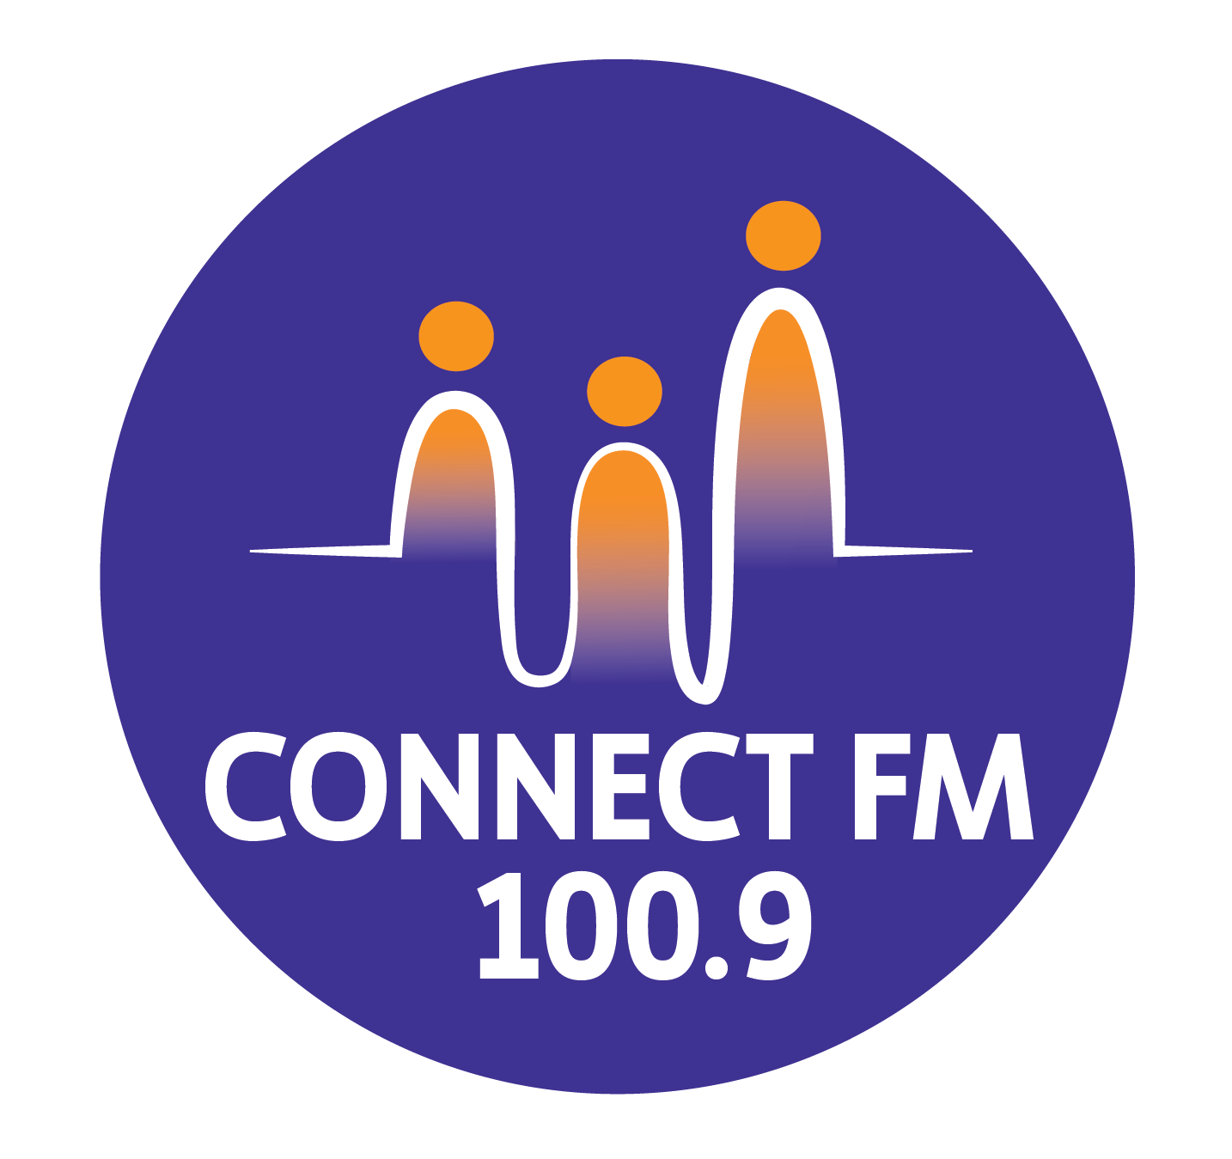
BANKSTOWN-AUBURN COMMUNITY RADIO INCORPORATED (BACR)
ABN 35 737 985 863

POLICY 2.2: COMMUNITY PARTICIPATION AND ENGAGEMENT STRATEGY

1. Objectives and Scope
- The primary goal of this policy is to motivate and support the residents, groups, and organizations of the Bankstown and Auburn areas to participate in the programming, operations, and decision-making of ConnectFM 100.9.
- BACR recognizes that successful community radio depends on:
- Getting started: Motivating new individuals and groups to join the station.
- Active Input: Assisting participants in completing the tasks or programs they wish to contribute.
- Sustaining Commitment: Nurturing long-term involvement to ensure a diverse and stable service.

2. Principles of Participation
- BACR values the diversity of skills and expertise within our community and uses these to inform station management and programming.
- Lived Experience: We prioritize the inclusion of individuals with relevant lived experience when producing programs concerning specific community groups or social issues.
- Democratic Management: Participation enhances, rather than replaces, the formal decision-making responsibilities of the Management Committee.
- Accessibility: We provide equal opportunity for participation to all parts of the community, ensuring our processes are flexible and inclusive.

3. Mechanisms for Active Involvement
- To facilitate participation, BACR utilizes structured "mechanisms" including research, collaboration, and role clarification.

Outreach and Media Actions
- Local Press: Every 6 months, paid advertisements and media releases will be sent to local newspapers (e.g., The Torch, The Review) to invite community involvement.
- Digital Strategy: All promotional materials will feature the station’s website and email to ensure digital accessibility.
- Direct Invitation: The Publicity and Promotions Officer will contact a minimum of 15 local groups or individuals every 6 months to invite program participation.
- Stakeholder Networking: We maintain a "List of Stakeholders" (Police, schools, religious groups, etc.) and will contact at least 10 annually to seek their involvement.
Leadership and Consultation
- Political Engagement: We seek interviews with local Mayors annually and with State/Federal politicians every 2 years to maintain community networks.
- Council Collaboration: Every 6 months, we consult with Council Multicultural and Media Officers to discuss community trends and participation needs.
- Open Days: An annual "Open Day" will be held to allow the public to tour the studios and learn about volunteer and membership opportunities.

4. Financial Inclusion
- To ensure that financial status is not a barrier to participation:
- Low-Fee Structure: Membership and airtime fees are kept at a minimum to support financially disadvantaged participants.
- Fee Waivers: In accordance with our 2026 Open Membership policy, individuals experiencing documented hardship may apply for fee assistance or waivers.
- Ethnic Grants: CBF Ethnic Grant funds are distributed equitably to multicultural broadcasters to subsidize program costs.

5. Collection of Evidence (Audit Compliance)
- BACR will document all efforts to encourage participation to meet ACMA and CBAA audit requirements.
- The Publicity and Promotions Officer is responsible for maintaining the Community Engagement Log, which includes:
- Records: Minutes of meetings, letters, emails, and diary notes of community contacts.
- Media Proof: Copies of newsletters, flyers, newspaper advertisements, and "on-air" announcement logs.
- Impact Data: Tracking the number of active volunteers, members, and diverse interest groups presenting programs

APPROVED BY THE BACR/CONNECT FM 100.9/CONNECT FM 100.9/CONNECT FM 100.9/CONNECT FM 100.9 MANAGEMENT COMMITTEE 2010/REVISED BY THE MANAGEMENT COMMITTEE 2025/UPDATED FOR 2026 COMPLIANCE

