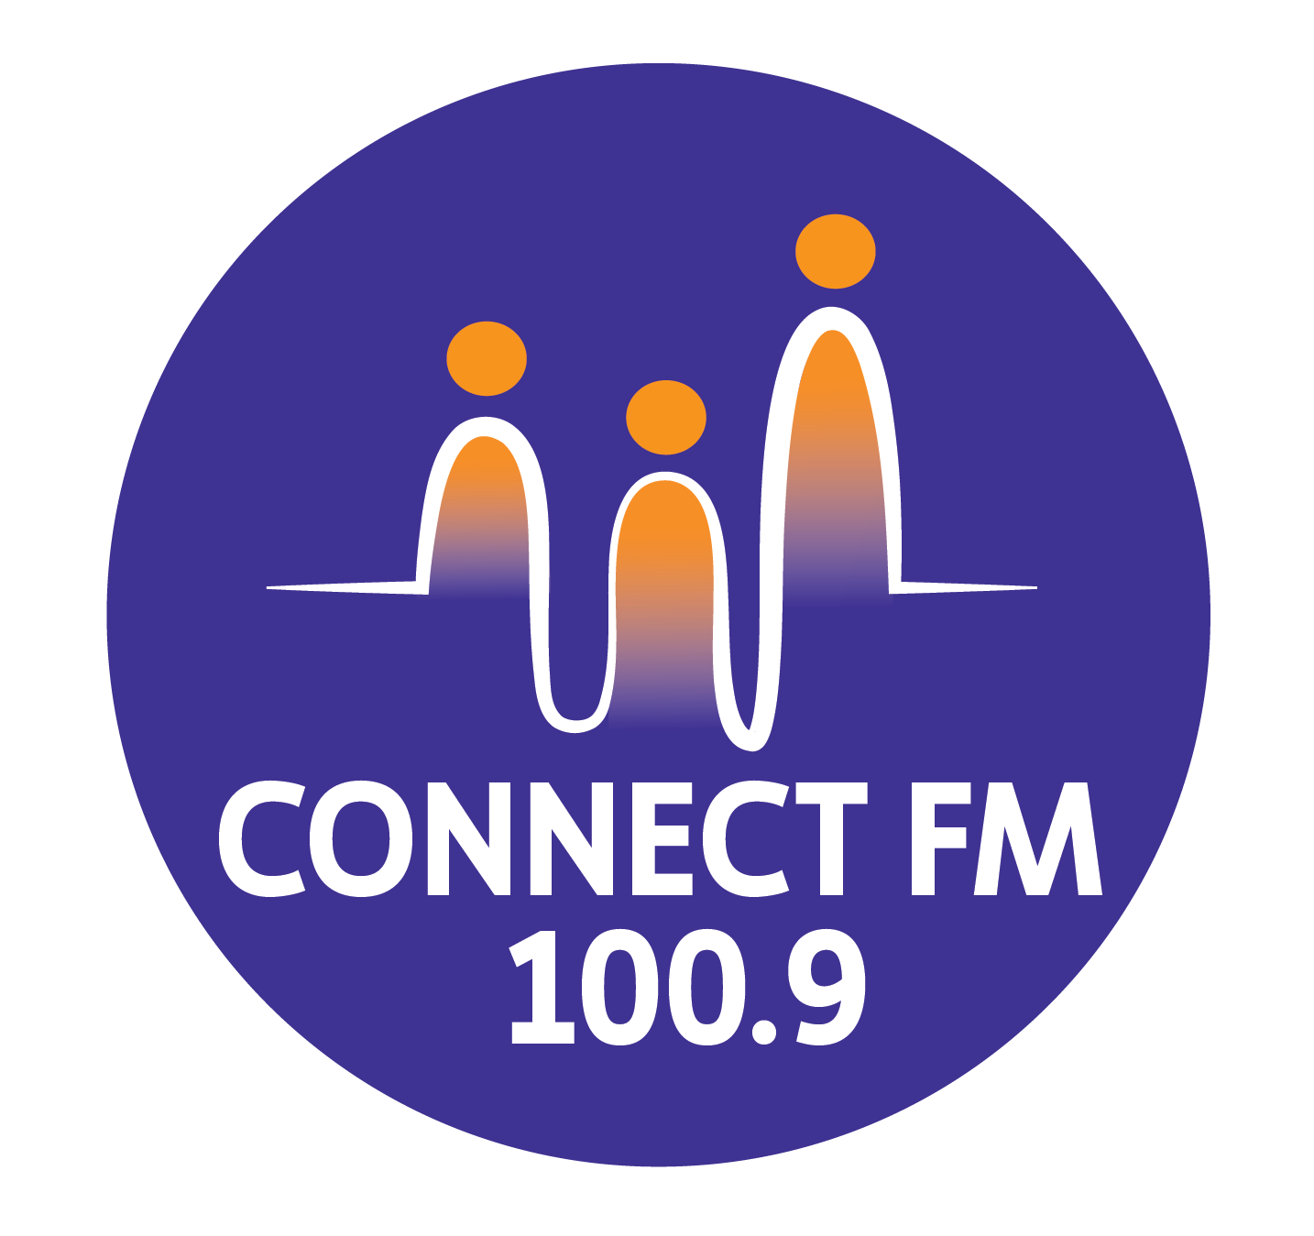
BANKSTOWN-AUBURN COMMUNITY RADIO INCORPORATED (BACR)
ABN 35 737 985 863

POLICY 6.1: SPONSORSHIP AND EDITORIAL INDEPENDENCE (REVISED 2026)
1. Purpose and Statutory Compliance
The purpose of this policy is to ensure ConnectFM 100.9 complies with the Broadcasting Services Act (BSA) and the 2025 Community Radio Codes of Practice.
- No Advertising: As a community broadcaster, the station is prohibited from broadcasting "advertising".
- Sponsorship Quota: Sponsorship announcements are strictly limited to five (5) minutes in any one hour.
- Mandatory Tagging: Every announcement must be clearly "tagged" to identify the financial or in-kind relationship with the sponsor.
2. Editorial Independence (2026 Standard)
To maintain community trust and prevent commercial influence:
- Absolute Independence: Editorial decisions regarding the content, style, and individual presenters of any program remain the sole responsibility of the station and are never influenced by sponsors.
- Access Equity: Sponsorship is never a factor in deciding who is granted broadcasting time.
- No Call to Action: To distinguish sponsorship from prohibited advertising, announcements must avoid "calls to action" (e.g., "Buy now" or "Visit us today") and focus on factual information about the sponsor's support.
3. Prohibited and Restricted Sponsorship
- Prohibited: We do not accept sponsorship from companies promoting tobacco, gambling, or illegal substances.
- Alcohol: Alcohol sponsorship is permitted only if it does not promote misuse and is not directed at minors.
- Values Alignment: Sponsorship will not be accepted from groups whose policies are inconsistent with station values.

REVISED ATTACHMENT 1: SPONSORSHIP AGREEMENT (2026)
BETWEEN: Bankstown-Auburn Community Radio Inc (ABN 35 737 985 863)
AND: _________________________________________________ (The Sponsor)
Standard Terms and Conditions
- Compliance: All material must conform to the Broadcasting Services Act (1992) and the CBAA Codes of Practice.
- No Advertising Clause: The Sponsor acknowledges that announcements must not contain "Calls to Action" or promotional pricing. Content is restricted to factual descriptions of the sponsor’s business and their support of the station.
- Tagging: Every announcement must include a tag (e.g., "[Sponsor Name] is a proud sponsor of ConnectFM 100.9").
- Editorial Control: The station retains absolute discretion to edit, amend, or refuse any material to ensure it meets community standards and legal requirements.
- Payment: Fees are payable in full according to the agreed schedule. Failure to pay will result in the immediate cessation of announcements.
- Indemnity: The Sponsor indemnifies the station against all legal actions arising from the content supplied by the Sponsor.
Sponsorship Package Details
- Contract Length: __________ weeks.
- Announcement Length: __________ seconds.
- Spots Per Day: __________
- Total Package Cost: $__________
Signed (Sponsor Representative): __________________________ Date: //2026
Signed (For ConnectFM 100.9): __________________________ Date: //2026

APPROVED BY THE MANAGEMENT COMMITTEE 2010 / REVISED FEBRUARY 2026 / UPDATED MARCH 2026

Attachment 1 to Policies and Procedures on Sponsorship

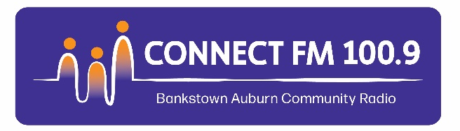
Bankstown-Auburn Community Radio Incorporated
ABN 35 737 985 863
Shop 1, 78 Cahors Road
Padstow NSW 2211
Sponsorship Agreement

This agreement is between Bankstown-Auburn Community Radio Incorporated
(ABN 35 757 985 863) and

Name of Sponsor/Organisation
x

Sponsor ABN
x

Address
x

Contact Name Phone Number
X x

Email
x

We agree to the fees, terms and conditions of the attached Agreement.

Signed and dated by an authorised sponsor representative
x x x

Print name Signed: Date:

Signed and dated by an authorised Connect FM 100.9 representative
x

Print name
x

Terms and Conditions

The agreement for Sponsorship shall be subject to the following general terms and conditions.

- All scripts, copy, recorded material or other material to be broadcast shall conform to the directions issued by the Australian Communications and Media Authority pursuant to the Broadcasting Services Act (1992). These directions stipulate that:
- No more than 5 minutes of Sponsorship announcements shall be broadcast in any period of an hour.
- Each Sponsorship announcement must contain a ‘tag’ specifying the financial relationship between Sponsor and the station.
- The telephone number of a Sponsor may be included in the Sponsorship announcement broadcast for that Sponsor.
- Tags and contact details must be included in the time limit of announcements

- The station in its absolute discretion may at any time edit, amend, censor or modify in any other way whatsoever any script, copy, recorded message, talk, address, pre-recorded program or other material without having to give any reason for so doing and shall not incur any liability for so doing.

- The station in its absolute discretion may at any time or from time to time decline to broadcast or rebroadcast any Sponsorship announcement without having to give any reason for so doing and shall not incur any liability for so doing.

- The broadcasting of any Sponsorship announcement in an edited, amended, censored or modified form whether by accident or otherwise shall not give rise to any liability on the part of the station nor shall it relieve the Client in any way from his obligation to pay for the broadcast of the Sponsorship agreement provided however that if such a broadcast contained a factual error made by the station then the station shall if required so to do by the client correct the error at the earliest suitable time.

- Failure of the station for any reason whatsoever to broadcast a Sponsorship announcement shall not give rise to any liability on the part of the station. The client however shall not be liable to pay the station as if the Sponsorship announcements were broadcast.

- Payment shall be at the rates stipulated by the station at the time at which this agreement comes into operation subject to any variation thereof provided that the Sponsor is given not less than four (4) weeks written notice of any such variation.

- This agreement shall be automatically terminated in the event of the suspension or cancellation of or failure to renew the broadcasting license of the station or if the station shall go into liquidation other than for the purpose of amalgamation or reconstruction or if the station shall cease to carry on business as a broadcasting station and as from the date of such suspension, cancellation, failure to renew, liquidation or cessation as the case may be.

- The termination of this agreement shall be without prejudice to any accrued rights or liabilities of the station or client.

- The client agrees to indemnify the station and keep it indemnified against all actions, suits, proceedings, claims, demands, damages, costs and expenses which may be taken made or awarded against it or incurred or become payable by it arising out of or consequential upon or incidental to the broadcast of anything supplied by the client.

- The client and the station each acknowledge that this agreement constitutes and records the entire understanding and agreement between them as to its subject matter. The client and its agents acknowledge that no employee or agent of the station or other person has been or is authorized to give any warranty, agree to any conditions, or make any representations whatsoever, verbal or otherwise on the station's behalf unless expressly so authorized in writing by the station’s Board and management. In the event of any inconsistency between any quotation, booking, announcement, broadcast, account or other matter or thing and these terms and conditions then the latter shall to extent of such inconsistency prevail.

- No waiver by the station of any breach of any provision in this agreement shall operate as a waiver of any other breach of the same or of any other provision in this agreement. No waiver of any breach shall be set up by the agent or client against the station unless expressed in writing signed by an authorized representative for the time being of the station.

Sponsorship Package Agreement
On-air campaign for x

Date x
The following is a contract between x and Connect FM 100.9 – Bankstown Auburn Community Radio Inc, for a x week package as detailed in the Connect FM 100.9 Sponsorship Proposal
Sponsorship package
Contract length | Announcement length | Number of spots per day | Price per spot | Package cost
x | x | x |  | x

By arrangement, your fees are payable in full asap. Bonus spots are given at present to our existing sponsors when available:
- Commencement date x. Date tbc once first announcement is aired post production.
- Amount Due: $x and invoice to be sent under separate cover.
Our customised solution to your sponsorship brief covers:
- On-air sponsorship announcements as per our proposal x
- Pre-records or live reads x
- In compliance with the Community Radio Codes of Practice, sponsorship announcements cannot contain ticket prices, promote gambling and liquor.
- Inclusion on the connectfm.au website.
- Inclusion as a sponsor on shopfront window material.
- Inclusion on social media monthly.
- Inclusion on printed program guides in the upcoming runs.

Connect FM 100.9 retains ownership of the broadcast material. Release for use in other media is charged at a separate rate. A quote to vary or extend the length of campaign can be forwarded on request.
Next steps
Can you please sign the electronic Connect FM 100.9 Sponsorship Agreement and return it? Attached is your invoice for payment. We require a high resolution logo of your organisation please.
Thank you for your interest in sponsoring Connect 100.9FM. Best regards and welcome.
X
Management Committee Member
Ie Treasurer/President

Attachment 2 to Policies and Procedures on Sponsorship

Bankstown-Auburn Community Radio Incorporated
ABN 35 737 985 863
Shop 1, 78 Cahors Road
Padstow NSW 2211
Broadcaster Airtime Application
To: BANKSTOWN-AUBURN COMMUNITY RADIO INCORPORATED (BACR)

Your First Name: ……………………………………..

Your Surname: ………………………………………..

Your Address: …………………………………………………………………….

Suburb: ..…………………………………………..… Postcode: ………….

Your Telephone Numbers:

Home: …………………………………….. Work: …………………………………

Mobile: ……………………………………. Email: …….………………………….

Language Of Program: ………………………………………..
Content Of Program (e.g., mainly music, mainly talk): ……………………….

Broadcasting Times You Prefer (eg, 9 AM-11 AM): ………………………………

Availability Mon Tues Wed Thurs Friday Sat Sun
AM
PM

Do you want to make sponsorship announcements? (Yes/No) ……………….
If so, what is the name of your sponsor ………………………………………….
Are you a Pensioner (Yes or No): ……………
Are you broadcasting for a Non-Profit Organisation or charity? ………………
Do you receive a government broadcasting grant (Yes/No): ………………….
Other comments you want to make: ……………………………………………..
………………………………………………………………………………………..

* Airtime fees are payable one month in advance.

SPONSORSHIP ARRANGEMENTS

* I understand that if I want to make sponsorship announcements on BACR I must have received written approval for the sponsorship announcements from the BACR Committee and compliant with the Codes of Practice, or my program will be removed from the air.

Signed: ………………………………………. Date: / /
Return this form by mail or in person to Bankstown Auburn Community Radio Incorporated, Shop 1, 78 Cahors Road, Padstow NSW 2211 or email admin@connectfm.au
Attachment 3 to Policies and Procedures on Sponsorship

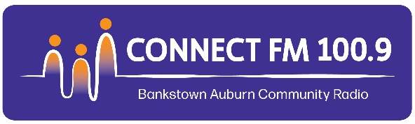
BANKSTOWN-AUBURN COMMUNITY RADIO INC
ABN 35 737 985 863
Shop 1, 78 Cahors Road | Padstow NSW 2212 | E admin@connectfm.au | W www.connectfm.au | T 02 9773 6670

BROADCASTER AIRTIME AGREEMENT

BETWEEN___________________________________________________________ (BROADCASTER)

AND BANKSTOWN-AUBURN COMMUNITY RADIO INCORPORATED (CONNECT FM 100.9)

I, the undersigned broadcaster, agree to fully comply with the rules, terms and conditions of my Broadcaster Airtime Agreement as specified within this Agreement and its Appendix 1 "Rules For Broadcasters, including Station CONNECT FM 100.9 Policies and Procedures" and Appendix 2 "Undertakings, Warranties and Acknowledgements", both of which form part of this Broadcaster Airtime Agreement.

Name of Program: …………………………………………………………………………………………………………………………………………………………….
Language of Program: ……………………………………………………………………………………………………………………………………………………….
Allocated Times and Days of the Program: ………………………………………………………………………………………………………………………..
Commencement Date: ………………………………………………………………………………………………………………………………………………………
Do airtime fees apply (Yes/No): …………………………………………………………………………………………………………………………………………
Cost per hour: $ ……………………………………………………………………………………………………………………………………………………………
I, the broadcaster, agree to pay my airtime fees one (1) month in advance and acknowledge that Bankstown-Auburn Community Radio can vary my airtime fees in accordance with CONNECT FM 100.9 pricing policies. I, the broadcaster, have read and consider that I understand the Rules, Policies and Procedures for broadcasting on community radio station CONNECT FM 100.9 (per Appendix 1) and I agree to comply with these rules, policies and procedures while ever I remain a broadcaster at Bankstown-Auburn Community Radio (CONNECT FM 100.9). I shall also comply with the undertakings, warranties and acknowledgements I give to CONNECT FM 100.9 (per Appendix 2). I, the broadcaster, understand that breach of the provisions of this Broadcaster Airtime Agreement can result in the suspension of my Program by Bankstown-Auburn Community Radio Inc. I, the broadcaster, understand that CONNECT FM 100.9, after giving to me 1 months notice in writ’ing; can vary my program dates and times.
Signed: …………………………………………………………………………………..
Print Your Name: ……………………………………………………………………
Date Signed: ……………………………………………………………………………
Signed on behalf of Bankstown-Auburn Community Radio Inc:

Signed: ……………………………………………………………………………………
Date Signed: ……………………………………………………………………………

