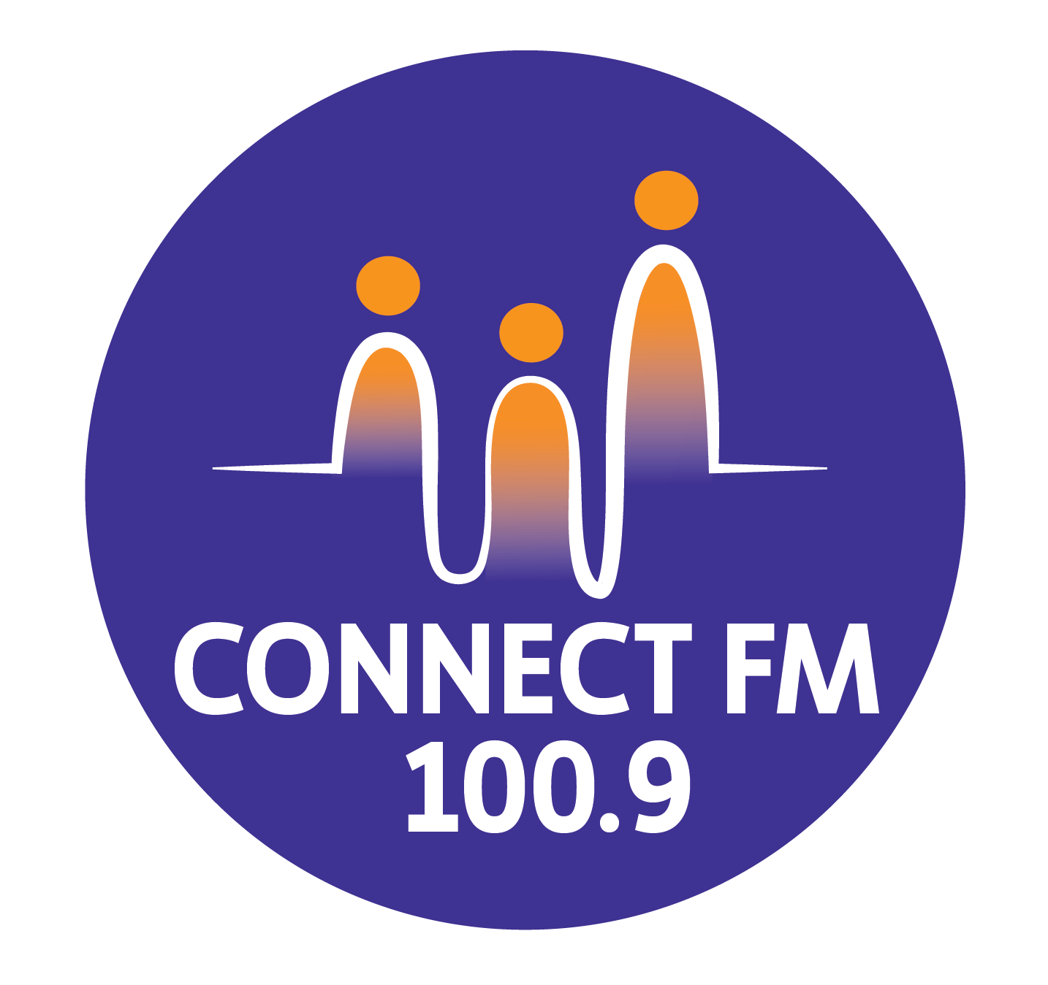
BANKSTOWN-AUBURN COMMUNITY RADIO INCORPORATED (BACR)
ABN 35 737 985 863

INFORMATION ON MULTICULTURAL GRANTS
1. Eligibility and Funding Share
- Grant Application: Multicultural grants are applied for by BACR/ConnectFM 100.9 on behalf of the station's ethnic broadcasters.
- Broadcaster Share: Once funds are received, the program producer is eligible for a minimum share of 25% of the grant amount.
- Fee Offset: At the broadcaster's request, this share may be used to pay for the program's airtime fees.

2. Core Eligibility Criteria (2026 Standards)
To qualify for funding, a program must meet these strict conditions:
- Regularity: Must be broadcast regularly (weekly, fortnightly, or monthly) on or before the grant submission date.
- Local Production: The program must be locally produced, contain high proportions of local material, and not be a re-presentation of a previously aired show.
- Spoken Content: At least 50% of the program must be spoken word.
- Lived Experience: The program must be produced and presented by individuals with relevant lived experience from the defined multicultural community it serves.
- Timeframe: Broadcasts must occur between 6:00 am and midnight.
- Compliance: Programs must comply with ACMA standards and the 2025/2026 CBAA Codes of Practice.

3. Specific Program Categories

Category | Presenter Requirement | Spoken Language Rule
Multicultural Program | Group accountable to a defined local community. | At least 50% in a language other than English.
Multicultural Youth | Entirely produced/presented by people under 30 years old. | 25% non-English (Year 1); 50% non-English (subsequent years).
Regional/Remote | At least 3 broadcasters from different backgrounds. | At least 10% in language/s other than English.

4. Compliance Monitoring

- Self-Monitoring: Broadcasters must regularly monitor their own programs to ensure they stay within funding guidelines.
- Audits: If the CBF or ACMA requests a program copy and it is found to be non-compliant, the program is deemed ineligible for the entire funding period.
- Cessation of Funds: If a program stops airing during the funding period, remaining funds are redirected to support other multicultural programs at the station.

APPROVED BY MANAGEMENT COMMITTEE 2010 / REVISED JANUARY 2024 / UPDATED MARCH 2026

