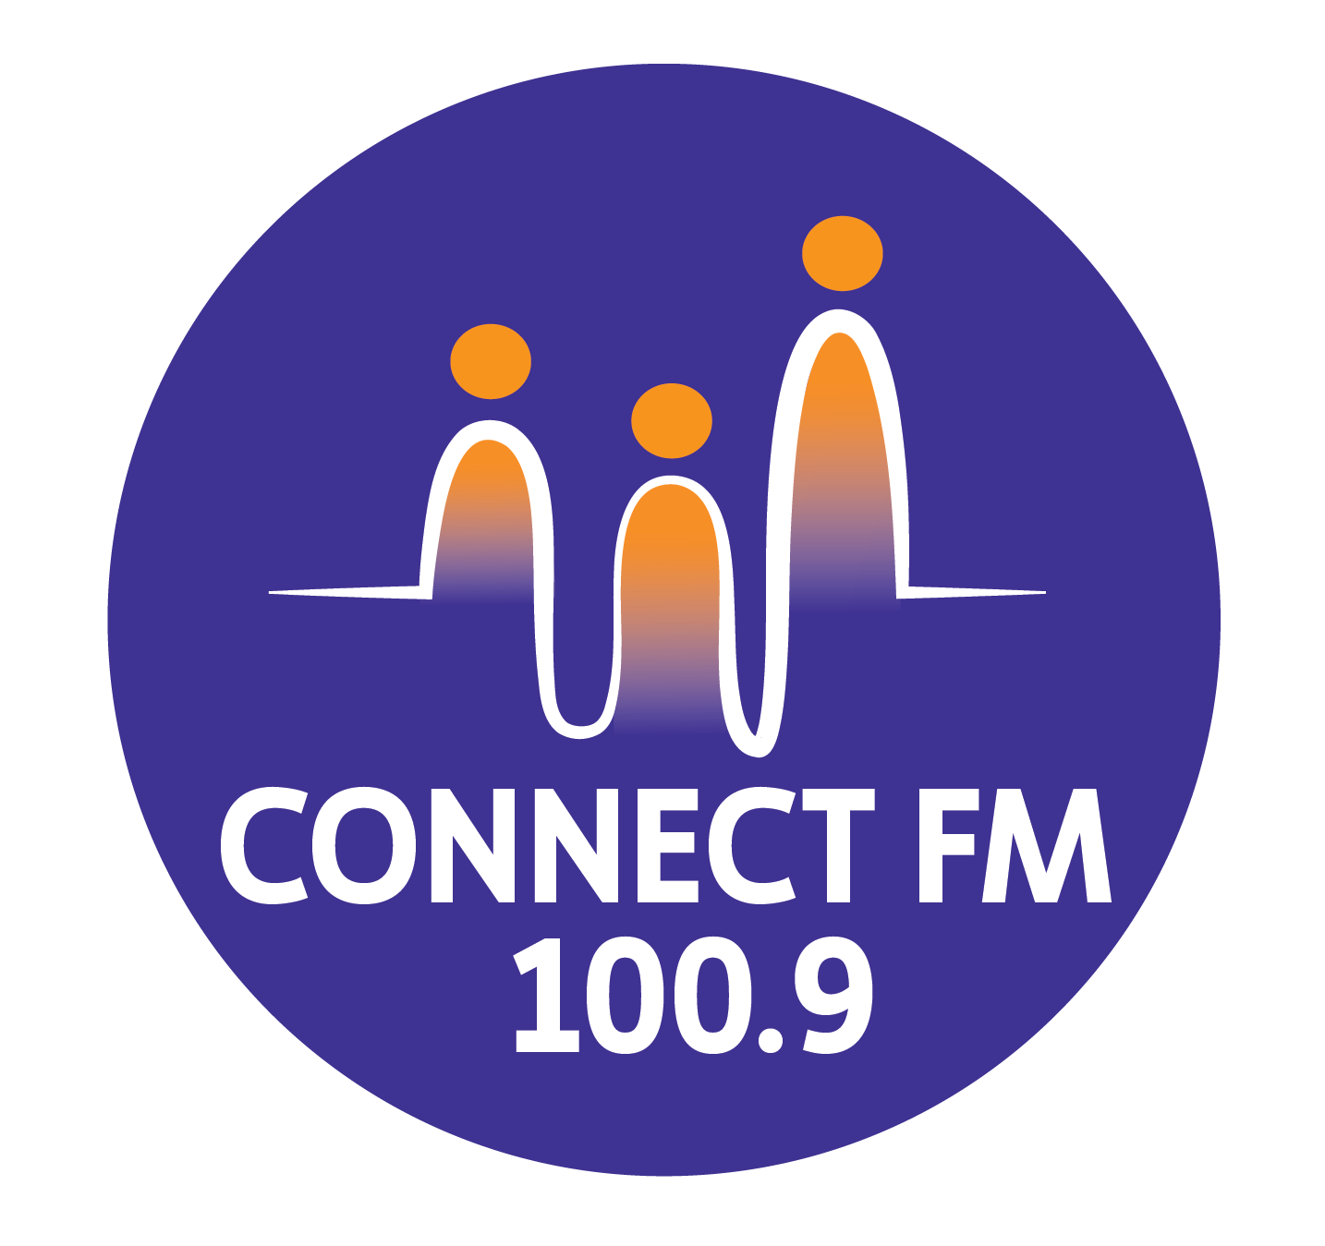
BANKSTOWN-AUBURN COMMUNITY RADIO INCORPORATED (BACR/CONNECT FM 100.9)
ABN 35 737 985 863

IMPORTANT INFORMATION FOR BROADCASTERS, VOLUNTEERS, AND MEMBERS (REVISED 2026)

1. Governance and Compliance
- Constitution: The Constitution of BACR/Connect FM 100.9 is published on the official website.
- Regulatory Framework: The station operates under the Broadcasting Services Act (BSA) and the Community Radio Codes of Practice.
- Policy Access: Detailed regulations are expanded upon in the Policies and Procedures Handbook, which is freely available at the station office and on the station website.
- Legal Obligations: There are strict government regulations regarding sponsorship formats, the prohibition of defamatory comments, and the prevention of material that vilifies or stereotypes any person or group based on ethnicity, gender, sexuality, or disability.

2. 2026 Programming Standards
To meet the updated 2025/2026 CBAA Codes, all participants must adhere to the following:
- First Nations Recognition: Broadcasters are encouraged to perform an Acknowledgement of Country at the start of their programs to respect the Traditional Owners of the land.
- Lived Experience: For programming concerning specific community groups (e.g., disability or multicultural issues), the station prioritizes "authentic voices" and individuals with relevant lived experience.
- Psychosocial Safety: Reporting on traumatic topics (such as suicide or violence) is a psychosocial hazard. Participants are entitled to, and encouraged to seek, a safety debrief with the Station Manager following such broadcasts.

3. ConnectFM 100.9 House Rules
All broadcasters, volunteers, and members must comply with the following internal regulations:
- Facility Respect: No consumption of alcohol, food, or drinks is permitted within the broadcast studios.
- Substance Policy: No smoking or consumption of illegal drugs is permitted anywhere on the premises.
- Professional Conduct: Avoid excessively loud or rowdy behavior; you are responsible for the actions of any guests you bring to the station.
- Public Interaction: Handle all calls and complaints from the public with respect, making no personal commitments, and referring issues to the Station Manager.
- Station Reputation: Act at all times to portray the station in a favorable light and avoid bringing the organization into disrepute.

4. Grievance and Dispute Resolution
- Internal First: Any person with a grievance against another announcer or a member of the Management Committee should submit the complaint in writing to the Board.
- Confidentiality: Broadcasters should not take complaints to outside organizations until the Board has dealt with the matter.
- Consequences: Bringing the station into disrepute via external complaints before internal resolution is viewed seriously and may result in disciplinary action.

APPROVED BY THE MANAGEMENT COMMITTEE 2010 / REVIEWED DECEMBER 2025 / UPDATED MARCH 2026

